Anatomy Scribe: James Tarbox
Date: 09/05/00 Proof: Sean Howell
Professor: Athos Colon, M.D Saved as: A090513

Congenital Malformation of Heart and Blood Vessels and Treatments

• 8 out of 1,000 live births have congenital malformations of the heart and blood vessels
• In adults, no significant congenital problem or have had surgery.
• Few cadavers will contain abnormalities other than acquired infarctions and minor necrosis from smoking

I) Region of Concern: Aortic Arch
Embryologically, humans start with 6 aortic arches.
Normally, 1, 2, and 5 regress
3, 4 and 6 give rise to important vessels of the head, neck, and upper thorax.

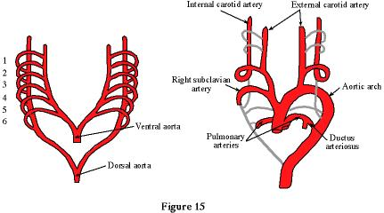

Mysterious cervical aortic arch. Pictures and data disappeared.

II) 4th aortic arch regresses- the arch will turn to the right.
The left carotid, right carotid and right vertebral artery come off the top of the aorta.
The right subclavian artery branches off laterally, while the left subclavian artery comes distally off the descending arch of the aorta.
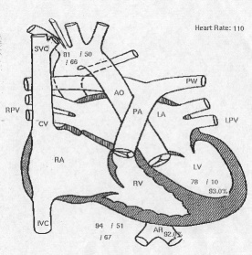

III) 5th aortic arch is persistent- two arches form in coarctation with the left usually hypoplastic (smaller). (Larsen fig 8-15)
Trachea and esophagus are compressed-vomit and asphyxia
A surgeon must cut the distal end of the hypoplastic arch and free the esophagus and trachea.

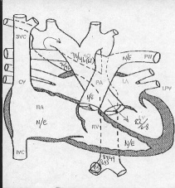

Ductus arteriosus connects from pulmonary trunk to left subclavian artery.
Ligamentum arteriosum wraps around the esophagus and trachea-vomit and asphyxia

Never say never.
Newborn with a completely occluded interventricular branch. Still alive in North Carolina and published.

10% of children who have a heart malformation also have renal malformation.
When dye is administered for the heart, the kidney region is usually checked too.
If a 3 yr old has a pelvic obstruction, no symptoms till the age 10, then scarred kidneys and hypertension.

IV) Two superior vena cavas (SVCs)- left SVC persistent (Larsen fig. 8-14)
Left SVC branches minimally with right SVW and empties into the coronary sinus.

People with two SVCs can live a normal life with the exception of having to notify their thoracic surgeons of their condition.

V) Ventricular septal defect (VSD)-blood crosses from the left ventricle to the right ventricle by a hole in septum. Dye injected into the left ventricle shouldn’t appear in the right ventricle. This accounts for 25% of all cardiac abnormalities.

VI) Transposition of the aorta and pulmonary trunk
1) Circulation is parallel not series, unless there is ductus arteriosus or hole in atrial septum.
2) Normal child appears large and healthy until the ductus arterosus closes.
3) A balloon on a catheter inserted through the foramen ovale of atrial septum, inflated and yanked (atrioseptosimy). Open atrial septum=deoxygenated and oxygenated blood mixing, prolonged life, and normalize pH.
4) Drugs-prostaglandins and dopamine can be administered to cause the ductus arteriosus to stay open longer.
5) Note: In hypoxia, blood pH is acidic (anaerobic=lactic acid) prostaglandins and dopamine are less effective.
6) Outcome better-normal blood pH, drugs, better surgery, opthomalogist sutures for coronary arteries, diagnose while fetal
7) If a child is born with transposition and a moderately sized atrial septum defect, there is mixing and thoracic surgery is usually only necessary.

VII) Critical pulmonic stenosis-muscles in the right ventricle become heavily trabiculated, hypertrophied, and obstruct the outflow track.
Increased pressure causes reflex through tricuspid valve into right atrium, inferior vena cava and hepatic veins.
Open a balloon between outflow track and pulmonary trunk in pulmonary valve.

VIII) Aortic valve stenosis- left ventricle collapses @ 200psi by obstructed outflow track. Coronary arteries take 3 heartbeats to perfuse. Fill in diastole.
Caused from coronary fibromatosis.

